Lighting Board Instructions
Center of the Golden One
Denver

Basic understanding of how the board works
The lighting board is DIGITAL which means that it works more like a computer than like a light switch.
THE FADERS (NUMBERED 1-48) CONTROL SEVERAL DIFFERENT THINGS AT THE SAME TIME UNLIKE A LIGHT SWITCH, WHICH ONLY DOES ONE THING: ON/OFF. The faders send a signal to the light with a number 1-10. Each number will tell the light what to do. The numbered button underneath the fader (BUMP BUTTON) will light up, with the intensity equal to the intensity of the light. (The small screen on top right will also show which faders are sending a signal out.) If you switch off the board with the faders up this will NOT turn off the lights in the room. The lights will stay set to the last number sent to them. That’s why it’s important to look at the numbered keys under the faders before you turn off the board. Any BUMP BUTTON this is lit means that a light is still on. The fader should be taken all the way down until the light goes out, BEFORE turning off the board.

THE WALL SWITCH IS NOT A LIGHT SWITCH. It has 10 presets. These are memorized positions of all the information on the light board when it was set.
To set a preset; hold the button down for 5 seconds and it will memorize all the settings on the board at that moment, to be recalled again when needed.
DO NOT USE THE WALL SWITCH WHILE USING THE LIGHT BOARD. The 10 preset switches are like mini lighting boards that send information to the same place the light board is sending information. When the signals get crossed this will confuse the light board and it can stop responding to ANY faders. At this point the light board will need to be reset to factory settings before it will work again.

HOW TO OPERATE COLORED LIGHTS

WALLWASH LED LIGHTS
- Faders 1, 2 and 3 mix colors between RED BLUE and GREEN. Use the color wheel reference below to create colors.
- Fader 4 is a selection of premixed colors. It overrides any setting on 1,2 & 3.
- Fader 5 controls STROBING of lights when the color has already been selected with faders 1, 2 and 3 OR 4.
- Fader 6 for different patterns of strobing colors as shown below. The “VALUE” column is numbers related to the positon of the fader. SOUND ACTIVATION is in each light. The lights will individually respond to sound and change colors at full intensity between R,G,B.
FADER | VALUE | FUNCTION
1 | 0  1-10 | OFF  RED  0%-100%
2 | 0  1-10 | OFF  GREEN  0%-100%
3 | 0  1-10 | OFF  BLUE  0%-100%
4 | 0-1  2-10 | NOTHING  PREMIXED COLORS of R, G & B  Different color mixes as you go up the fader
5 | 0-1  2-10 | NOTHING  STROBING Slow to Fast - OR the SPEED of Fader 6
6 | 3  4  5  7  8  9  10 | Patterns of color changes - Colors  DIM---BRIGHT Colors selected by 1,2,3 OR 4  BRIGHT---DIM Colors selected by 1,2,3 OR 4  DIM---BRIGHT---DIM Colors selected by 1,2,3 OR 4  COLOR MIXING Automatic color mixing  3 COLOR CHANGE R,G,B  7 COLOR CHANGE R,G,B.Y,C,M,W  SOUND ACTIVE MODE – cycles through RGB colors with the beat of the music. Each light is a different color, so is a very random affect. Colors will not change without music playing.  NOTE: FADER 5 will adjust the SPEED of the color changing when Fader 6 is activated

STAGE OR FLOORWASH LED LIGHTS
- Fader 7 controls STROBING of lights when the color has already been selected with faders 1, 2 and 3 OR 4. Set it to 10 or you won’t see any light.
- Fader 8 is the MASTER fader for the light. It must be set higher than 0 in order to see any light. You also have to choose the color of light before you will see any light.
- Faders 9-13 mix colors between RED, BLUE, GREEN, WHITE, AMBER, ULTRAVIOLET. Use the color wheel reference below to create colors.
- Fader 10 is a selection of 30 premixed colors. It overrides any setting on 1,2 & 3.

FADER | VALUE | FUNCTION
9 | 0  1-10 | OFF  RED  0%-100%
10 | 0  1-10 | OFF  GREEN  0%-100%
11 | 0  1-10 | OFF  BLUE  0%-100%
12 | 0  1-10 | OFF  WHITE  0%-100%
13 | 0  1-10 | OFF  AMBER  0%-100%
14 | 0  1-10 | OFF  ULTRAVIOLET  0%-100%
15 | 0-1  2-10 | NOTHING  30 PREMIXED COLORS  Different color mixes as you go up the fader
16 | 0-1  3  5  8  10 | Premixed Color Chase  Off  30 Color Chase  6 Color Chase  Color fade chase  off
17 | 1-10 | Color fade Speed  Chase speed of Channel 16 - slow to fast
18 | 1  10 | Dimming Modes  Standard  Stage  TV  Architectural  Theatre  No Function

MIRRORBALLS
Fader 19 FADE - controls light intensity;
from off to full brightness.
the light will strobe when the fader is lined up with the label STROBE on the side of the fader
Fader 20 SPIN - controls the spin of the ball
In the middle and at the top and bottom of the fader, the spin is off. From 1-5 on the fader spins the ball in one direction, from 5-10 on the fader spins the ball in the opposite direction. The speed of the spin increases as you move away from the 5 mark on the fader. It’s best to leave the fader at 5 for the off position, and move it up or down from there. Then the spin starts at slow and increases to fast. If you leave the fader at 1 and start from there, it spins the ball fast first then slow as you move up the fader.
Fader 21 COLOR - Controls the color of the light
There are several colors that the ball is capable of changing to. They are labeled to the side of the fader with the first letter of the color. R, G, B, stand for RED, GREEN and BLUE, or combinations of those 3 colors. Slide the fader to the corresponding letter to change to that color.
FADER | VALUE | FUNCTION
19 | 0-9  10 | POWER TO MIRROR BALLS  OFF  ON
20 | 0  2-4  5  6-9  10 | ROTATION  STOP  CLOCKWISE ROTATION FAST-SLOW  STOP  COUNTER-CLOCKWISE ROTATION SLOW - FAST  STOP
21 | 0-1  2-7  8  9-10 | DIMMER & STROBE  OFF  DIMMER 0% - 100%  STROBING FAST - SLOW  ON 100%
22 | these are approximate  1-2  2-3  3-4  4-5  5-6  6-7  9-10 | COLOR  RED  GREEN  BLUE  RED & GREEN  BLUE & GREEN  BLUE & RED  RED & GREEN

Here is an explanation of color theory and color mixing. https://youtu.be/Hbxy1W9O_Wk?t=30s you don’t have to watch the whole video just the explanation of how to mix colors with light.
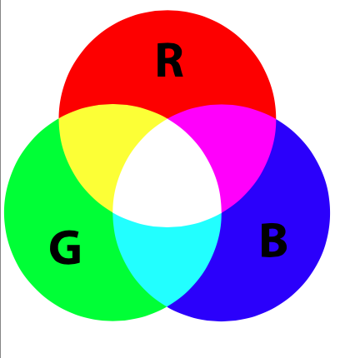

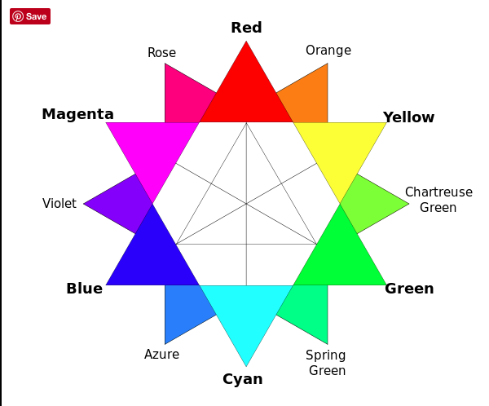

TROUBLESHOOTING

IF YOU CAN’T TURN A LIGHT ON
- Check that 1-48 button is lit
- Check to see if the button Labeled BLACKOUT is on.
The blackout button will turn off all lights in the room. This button is used when you want to turn the theatre dark instantly. If the button is on you won’t be able to control any lights.
- Check that the fader at the extreme right, labeled MAIN is all the way up.

IF YOU CAN NOT TURN A LIGHT OFF

- Check that the wall switch has no buttons on. If a button is lit, press the button to turn it off.
- Check that 1-48 bump button is lit on the board
- Move the fader (for the light that is on) all the way to the top and back to the bottom. This will clear any leftover information that has been sent to the light previously.
- Press the CLEAR Button 3 times to turn off all lights that are on in the room. If you loose control of the lights, or cannot turn any lights off then you can clear all the information that is currently being sent out by the board. Pressing clear 4 times will return all the faders to zero.
- (It is a good practice to press clear 4 times when shutting down the board. If after you turn off the board and see that some lights in the room are still on, turn the board back on and press clear 3 times to zero out all information sent to the lights. )

IF the board is NOT RESPONDING at all to anything you try:
do a FACTORY RESET on the board. DO THIS IS AS A LAST RESORT. Doing this will not affect the lights in the room that are on until the operation is complete and the board is restored. It will ERASE all the information recorded in the board AND it will have basic function again. The faders will now control the lights in its most basic setting and will not correspond to the labels on the board until you load the saved information back into the board.
- Shut off light board by pressing MODE and then YES
- Hold down MODE button AND MENU button as it starts up in test mode
- Press YES button (same as MENU) several times as it runs tests. Look at the screen to see where it is in the test process
- Continue to press YES until board restarts
- When it restarts press the STACK button (yellow button in this picture) to turn OFF stack function (light on stack button will go out). This is important to do or you won’t have control.
- Press (MENU) YES button and turn wheel underneath window on the right until you see: MENU
SAVE/ LOAD SHOW in the window.
- Press YES/(MENU)
- Turn wheel again until LOAD SHOW appears in the window.
- Press YES
- SELECT FILE NAME will appear in the window
- Turn wheel again until #1 appears
- Press YES to load Show #1 into the memory.
This comes from the SD card that is inserted into the top of the light board. If NO FILE Appears in the window make sure the SD card is in the slot under the window.
Note: If you can’t LOAD SHOW #1 you will still have control of the lights, but they will revert to the 1-24 faders The differences will be:
1. Wall Sconces will be controlled by #9 and #14 faders.
2. No Mirror Ball, or colored light will work
3. Stage lights will be 1-8
4. Fluorescent lights will be 20-24
5. Altar lights will be 10, 12, 13, 16-19

